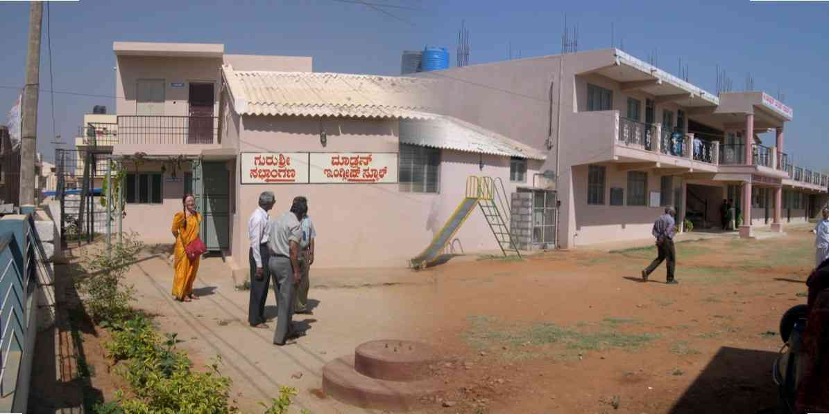

News from
Prof. Muchukunte T. Krishnamacharya (Mysore)
Memorial Trust International (Regd.)
(A non-profit educational and cultural trust)

1. Offering of financial assistance to set up a Reading Library in a Karnataka Government recognised educational institution in Bangalore city. Initial cost voted by your Trust: Rupees 50000,00. The project includes purchase of reading books, dictionaries, and other reading and library materials needed from the Nursery class to 7th Standard. The Reading Library would also be opened to the public of the locality. The Library would be commissioned in July 2004 when the school reopens after the summer holidays.
2. Organisation of Annual debate in Sanskrit at the Mysore Maharaja’s Govt. Sanskrit College with Cash prizes and certificates to the best participants.
3. Offering a monthly salary to a schoolteacher in a Fisherman’s village in Tamil Nadu.
4. Providing free medical aid to children of Fisherman’s village in Tamil Nadu.
5. Projects under study: Organisation of religious and philosophical debates on Ramayana and Bhagavad Gita in Bangalore; Organisation of free Ayurveda consultancy and medication in villages near Bangalore City; Free medical eye-examination and offer of corrected eye-glasses to primary school students.

